Places to stay
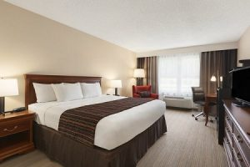I recommend the Country Inn & Suites in Lehighton, PA. Call them at (610)379-5066 to make a reservation and tell them you are with the Acanthus Workshop. The hotel is 8 miles south of the shop and is conveniently located just off the Mahoning Valley exit of I-476 (the northeast extension of the PA turnpike). The rooms are a reasonable size and very clean. They provide breakfast (and lunch each day is part of your class) and the hotel is only a few miles from the town of Jim Thorpe where you'll find shops and restaurants worth exploring.
Directions from the Country Inn & Suites: Turn right out of the parking lot and travel .2 miles to the light at Harrity Rd. turn left. Take Harrity Rd. for .6 miles and turn right onto Fairyland Rd. In 400 feet, turn left onto Overlook Dr. In 1 mile, turn right onto Indian Hill Rd. In .7 miles Indian Hill Rd. becomes Maury Rd (at the stop sign) – continue straight onto Maury Rd. for 2.5 more miles. Maury Rd. ends at Rt. 903; turn right onto Rt. 903 North. In 1.1 miles turn left onto Behrens Rd. and, in another 1.1 miles turn right onto Indian Trail Rd. Stay on Indian Trail Rd. by bearing slightly to the right for .3 miles and #62 in on the right (the shop is in back of the house – green house with large front porch).
Additionally, there are numerous bed and breakfasts in the Jim Thorpe area as well as entire homes for rent in (and near) our community of Bear Creek Lake Civic Association. Homes and B&Bs can be located and booked through a variety of websites like – airbnb.com and bedandbreakfast.com and searching the Jim Thorpe area.

